**SSRS Accounting Sales Report (pull data from DB2 Database)**

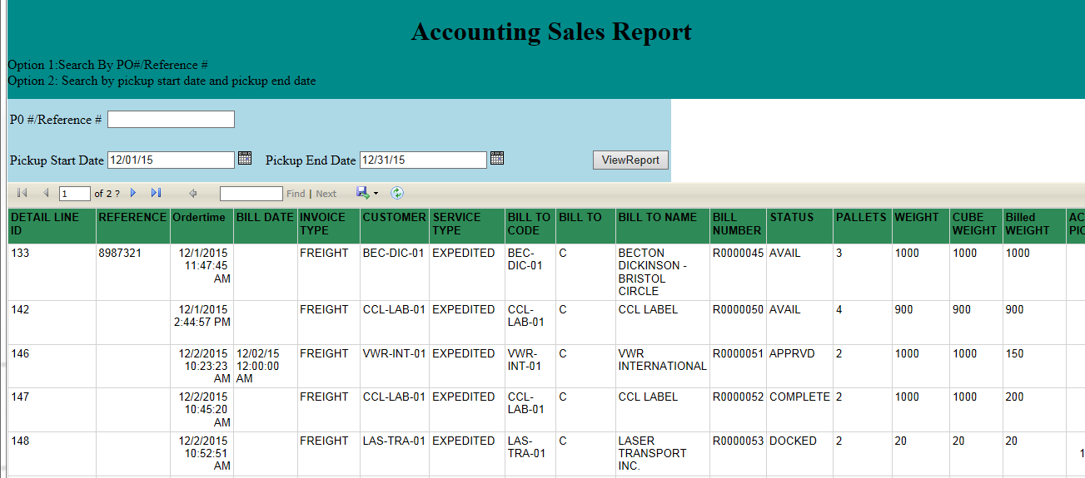

When a user enters a pickup Start Date and pickup End Date, and click on “View Report”, then a sales report which pulls data from our DB2 database will be generated.

**Techniques Used (pull data from DB2 Database)**

I used report viewer control of C# to make SSRS report displayed on a web page